Abstract Template for ISCOM2022 (14 points, bold, centered, single line spacing and maximum two lines)
Blank line (12 points)
Presenting Author,¹ Second Author¹, Third Author², …
Blank line (12 points)
¹ Institution, Address, Postal-Code City, Country, e-mail: Presenting.author@inst.pt
² Institution, Address, Postal-Code City, Country
Blank line (12 points)
Please write your abstract for ISCOM2022 using this template.
The abstract should be 1 page long (maximum) in the A4 standard format, portrait layout, top margin 3 cm, left, right and bottom margins 2.5cm.
Please use single line spacing and Times New Roman or Times Roman font throughout the abstract. The title font size is 14 points, bold, centered and two lines maximum. After the title leave a blank line, 12 points size.
The authors list is 12 points font size, bold, centered and the presenting author underlined. Leave a blank line, 12 points font size, separating the authors from the affiliations.
Affiliations list is 11 point font size, italic and centered. A full postal address (including the e-mail) should be given for the presenting author.
A blank line, 12 points font size, separates the affiliations list from the main text. The main text is written in 12 points font size, one-column format. (Using style Abs_Body).
The text should describe in a clear and concise way the work to be presented. The use of figures, tables and schemes is encouraged to help the understanding of the work. References are indicated in the text by Arabic numbers between square brackets [1] and should be listed at the end of the text using standard Science Citation Index format. Captions and references, if necessary, are written in 10 points, font size.
Name your Abstract as OC_Name_Surname.doc, if you apply for an oral communication, or PP_Name_Surname.doc, if you apply for a poster presentation.
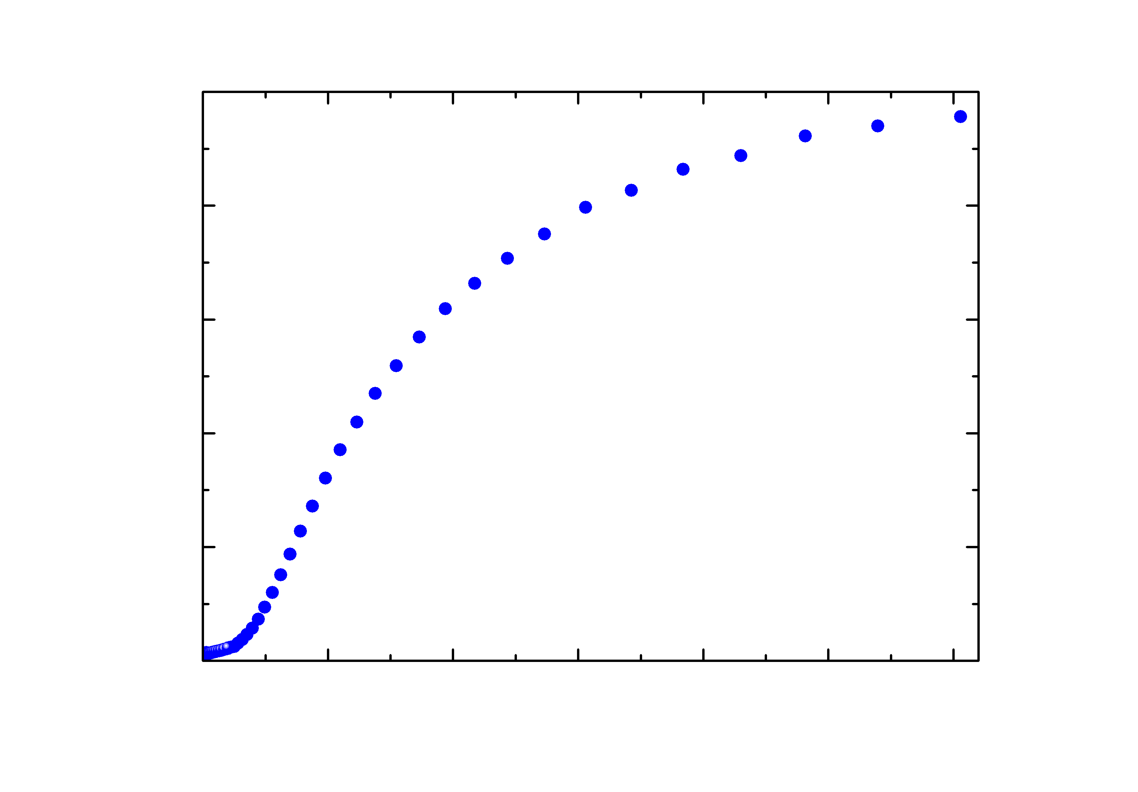
Fig. 1. Caption.

References
- N.V. Unknown et al., Journal Title Vol., page (year). (Using Style Abs_Ref)
- J.W. Blabla et al., Journal Title 186-187, 1658 (1989).

